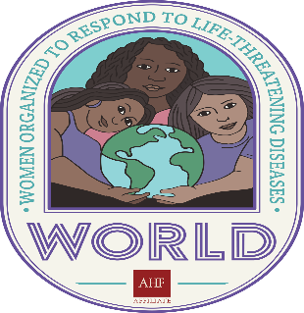
WORLD Leadership Institute Application
_______Spring Session _______Fall Session

Contact Information:
To help us process your membership application, please provide all of the information requested and type or print clearly.
Name: | Mailing Address: | City/ State/ Zip Code:
County: | Contact Phone Number: | Contact E-Mail:
Employer if Applicable: | Employer Address: | Employer Contact Info:
Title:

Demographics:
I am: ___Cis Female (a woman who was assigned female at birth)
___Transgender Female (a woman who was not assigned female at birth)
___Gender non-conforming (someone who doesn’t identify with a designated gender)

My age range is: ___13-19 ___20-29 ___30-39 ___40-49 __50-59 ___60+

I am a person living with HIV/ AIDS (PLWHA) (optional): ___Yes ___No
Disabling HIV/ AIDS: ___Yes ___No

If you are a person living with HIV, are you comfortable disclosing your HIV+ status to others outside of the Leadership Institute? ___Yes ___No

*Disclosure of HIV status is encouraged, but not required for membership.

I am a person living with Hepatitis B: ___Yes ___No
I am a person living with Hepatitis C: ___Yes ___No
I am a person living with a current or previous diagnosis of an STI/STD: ___Yes ___No

Please check all that apply (optional): ___Herpes ___Gonorrhea ___Syphilis
___Genital Warts ___Other

Do you have any special needs/ disabilities? ___Yes ___No
If yes, please explain what additional support/services you may need to be successful in the Institute:

Sexual Orientation (optional): ____________________________________ WORLD P&A 2021
Identified Race:
___Black ___Asian ___Other

___White ___Pacific Islander

___Latina/x) ___Native American

What makes you want to be a part of the WORLD Leadership Institute? (Feel free to use the back of this pager or an additional piece of paper if you need more room to respond):

Use this space to identify any councils, boards or advocacy groups that you are currently a member of, any leadership trainings that you have participated in, as well as any special skills/ expertise/ education that you feel as though you will bring to the WORLD Leadership Institute. (Feel free to use the back of this page or an additional piece of paper if you need more room to respond):

Please check all programs/ activities/ areas of interest/ expertise/ need more information as applicable:
___Advocacy/Awareness ___ Community Organizing

___Health Planning ___Evaluation of HIV or Health Services

___Public Health Administration ___Provider Perspective

___Dental Services and Needs ___Homelessness/Housing Services and Needs

___Substance Use/Abuse Services and Needs ___Mental Health Services and Needs

___PLWHA Nutritional Services and Needs ___PLWHA Legal and Financial Services and Needs

___Primary Medical Care: Ambulatory/Outpatient ___Primary Medical Care: Antiretroviral Therapies
___White MSM HIV Issues and Needs ___MSM of Color HIV Issues and Needs

___Women’s HIV Issues and Needs ___Children/Youth HIV Issues and Needs

___Transgender HIV Issues and Needs ___Ex-offender HIV Issues and Needs

___Immigrant/Migrant HIV Issues and Needs ___Other: _______________________ WORLD P&A 2021

What experience do you have working in the HIV/ STI Field/ Community:

Please provide 1 letter of reference (character/ performance), as well as one additional personal or professional reference:

Name of person providing the letter of reference:______________________

Contact Info: ______________________________

Best Time of Day to Contact: _____________________________

Name of Reference II: ______________________________

Contact Info: ________________________________

Best Time of Day to Contact: ____________________________

WORLD P&A 2021
Statement of Purpose: What do you look to get out of the WORLD Leadership Institute and what are your next planned steps upon graduation? Ex: applying to sit on a board, start a program, start a support group, do consulting, increase involvement in politics, etc.? (Feel free to use the back of this page or a separate piece of paper if you need more room)

WORLD P&A 2021

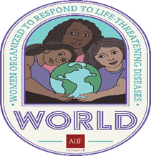

Return WORLD Leadership Institute (WLI) Application to:

Women Organized to Respond to Life-threatening Diseases (WORLD)
c/ o Dr. Demisha Burns (Office of Policy and Advocacy)
389 30th St.
Oakland, CA 94609
510 - 986 - 0340 (Office)
510-986-0341 (Fax)
www.womenhiv.org
info@womenhiv.org

WORLD P&A 2021

